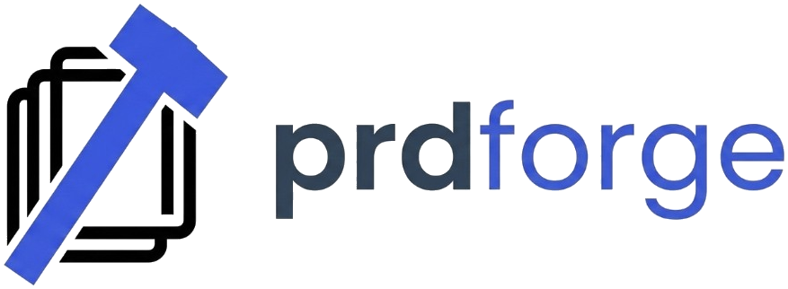

PRDForge Starter Pack

PRDForge helps you turn product ideas into execution-ready plans fast.

What this pack includes
1. Product brief template
2. PRD template
3. Technical architecture template
4. Delivery roadmap template
5. Task execution tracker

How to use
1. Start with `02-Product-Brief.md`.
2. Expand into `03-PRD.md`.
3. Define build approach in `04-Technical-Architecture.md`.
4. Sequence milestones in `05-Delivery-Roadmap.md`.
5. Track work in `06-Execution-Tracker.md`.

First 60-minute flow
- 15 min: fill product brief
- 20 min: complete PRD core sections
- 15 min: map architecture and risks
- 10 min: lock milestones + first sprint tasks

